1. Bot will enter the URL - <https://planningonline.npt.gov.uk/online-applications/>

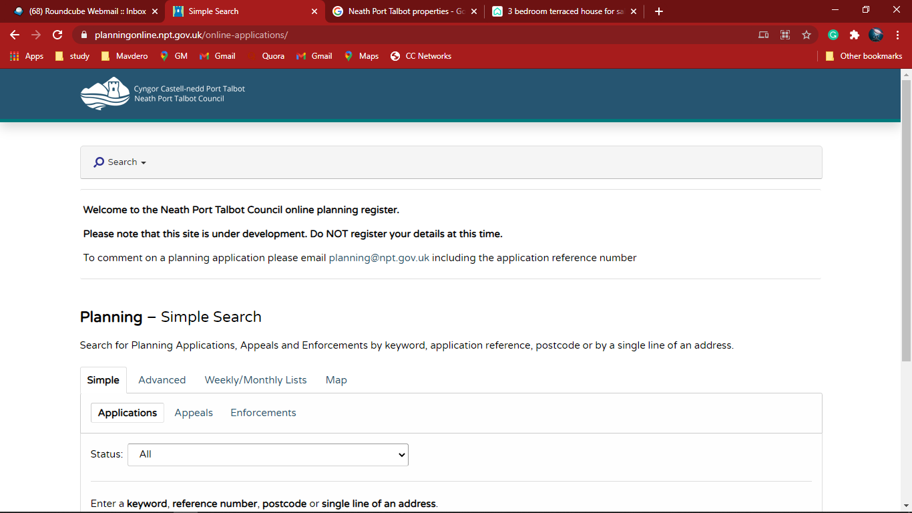

1. Bot will select “ALL” in Status

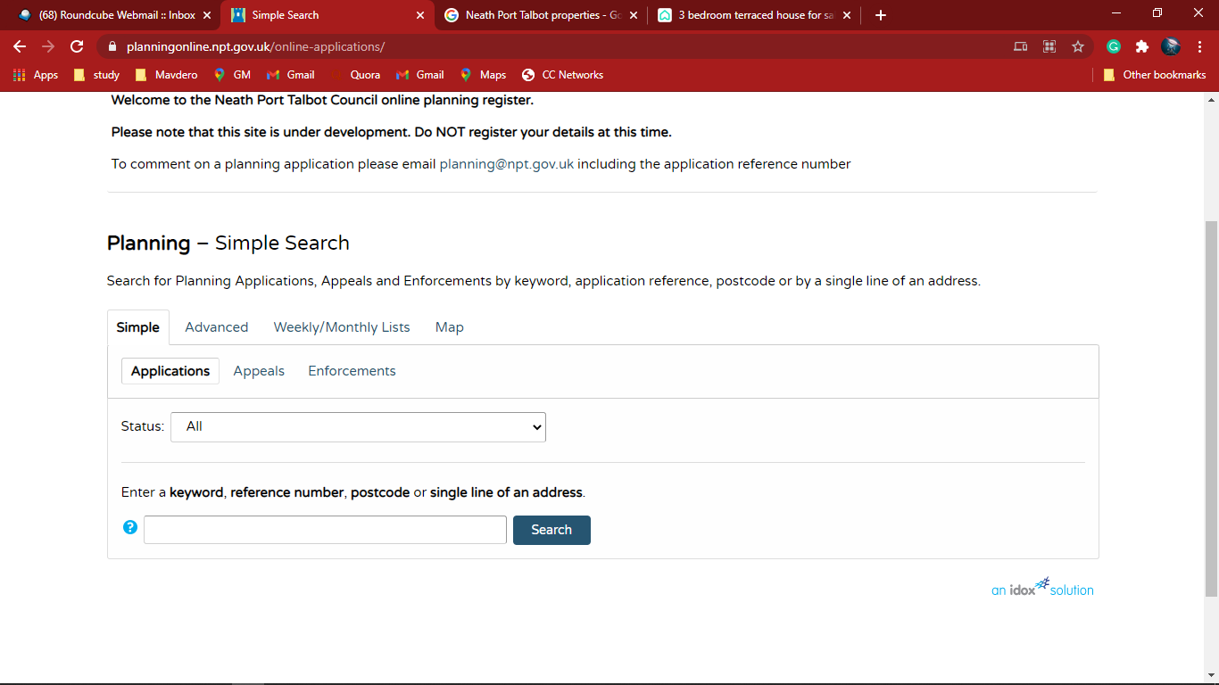

1. Bot will Enter the Postal code and click Search

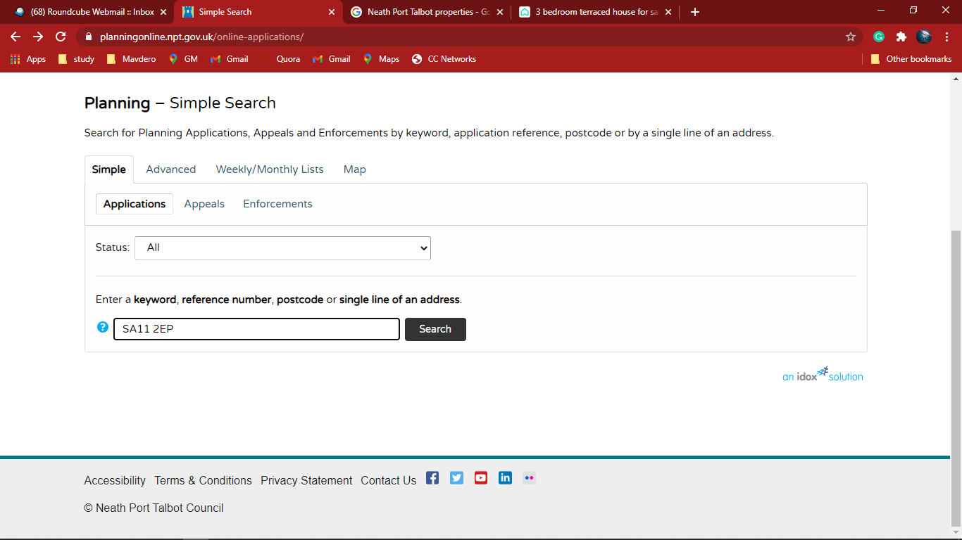

1. Bot will Select the Correct Address

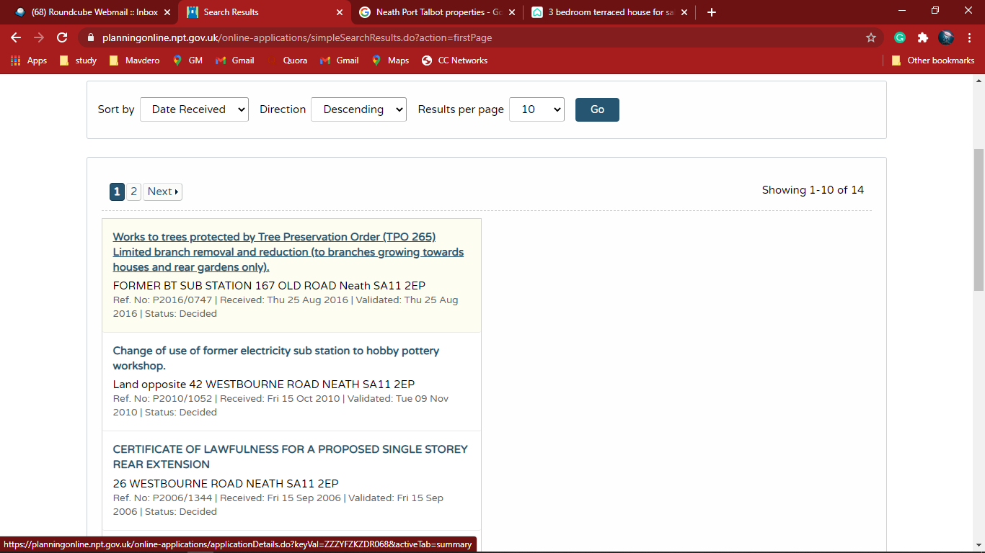

1. The Planning - Application Summary will show as follow

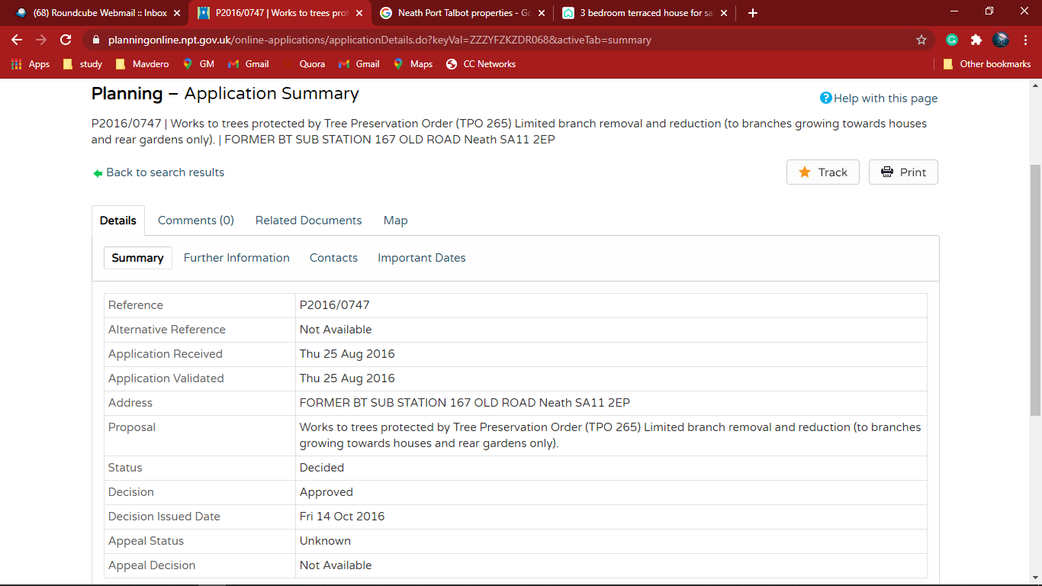

1. Bot will click and go to the Important dates

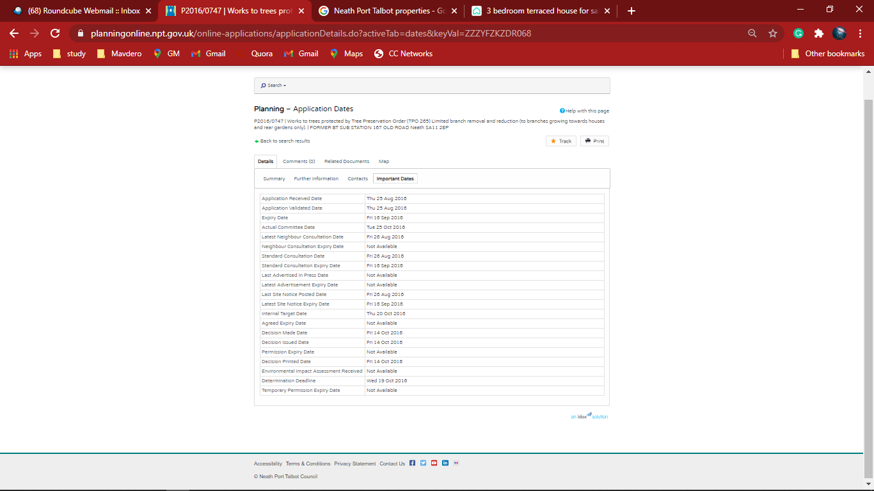

1. Bot will extract the data from Important dates and populate in excel

